**Nucor-Relay for Life (website)**

**User’s Manual**

**for IT Support Services**

Prepared by: Adam Moses

**Revision Sheet**

|  |  |  |
| --- | --- | --- |
| **Release No.** | **Date** | **Revision Description** |
| Rev. 0 | 12/4/2016 | User’s Manual Created |
|  |  |  |
|  |  |  |
|  |  |  |
|  |  |  |
|  |  |  |

**USER’S MANUAL**

**TABLE OF CONTENTS**

Page #

***1.0*** ***GENERAL INFORMATION***

**1.1** **Purpose 1-1**

***2.0*** ***WEBSITE NAVIGATION 2-1***

**2.1** **Nucor Relay for Life (Home page) 2-2**

**2.2 About Us 2-3**

**2.3** **Relay Teams 2-4**

**2.4** **Leader Board 2-5**

**2.5** **Events 2-6**

**2.5.1 Calendar 2-7**

**2.6** **Photo Gallery 2-8**

**2.6.1 Select Event 2-9**

**1.0 GENERAL INFORMATION**

**GENERAL INFORMATION**

**1.1** **Purpose**

The purpose of this manual is to show the User(s) how to navigate and know what to expect visually when navigating through the Nucor-Relay for Life website.

**2.0 WEBSITE NAVIGATION**

**WEBSITE NAVIGATION**

The following picture shows the horizontal menu bar located at the top of the page that consists of the following tabs to navigate the Nucor-Relay for Life website – *NUCOR RELAY FOR LIFE, ABOUT US, RELAY TEAMS, LEADER BOARD, EVENTS, PHOTO GALLERY.*

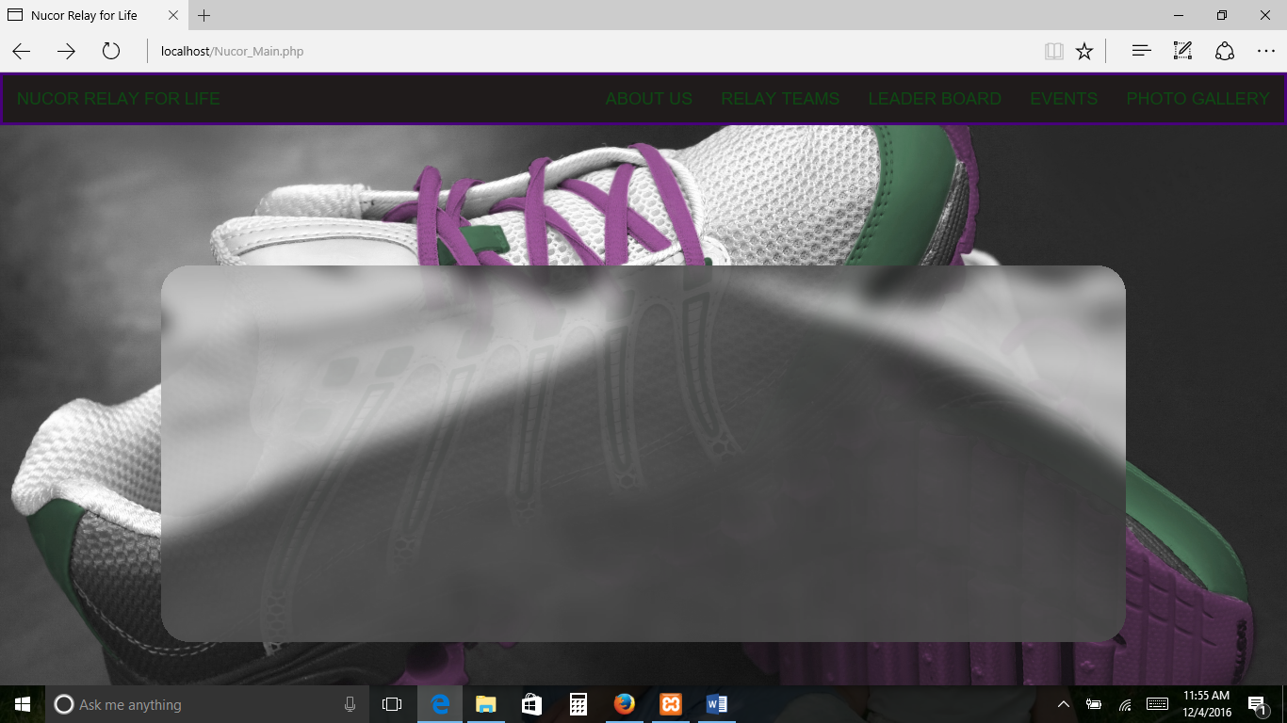

**2.1 Nucor Relay for Life (Home page)**

The following picture displays the output when the “NUCOR RELAY FOR LIFE” TAB is clicked

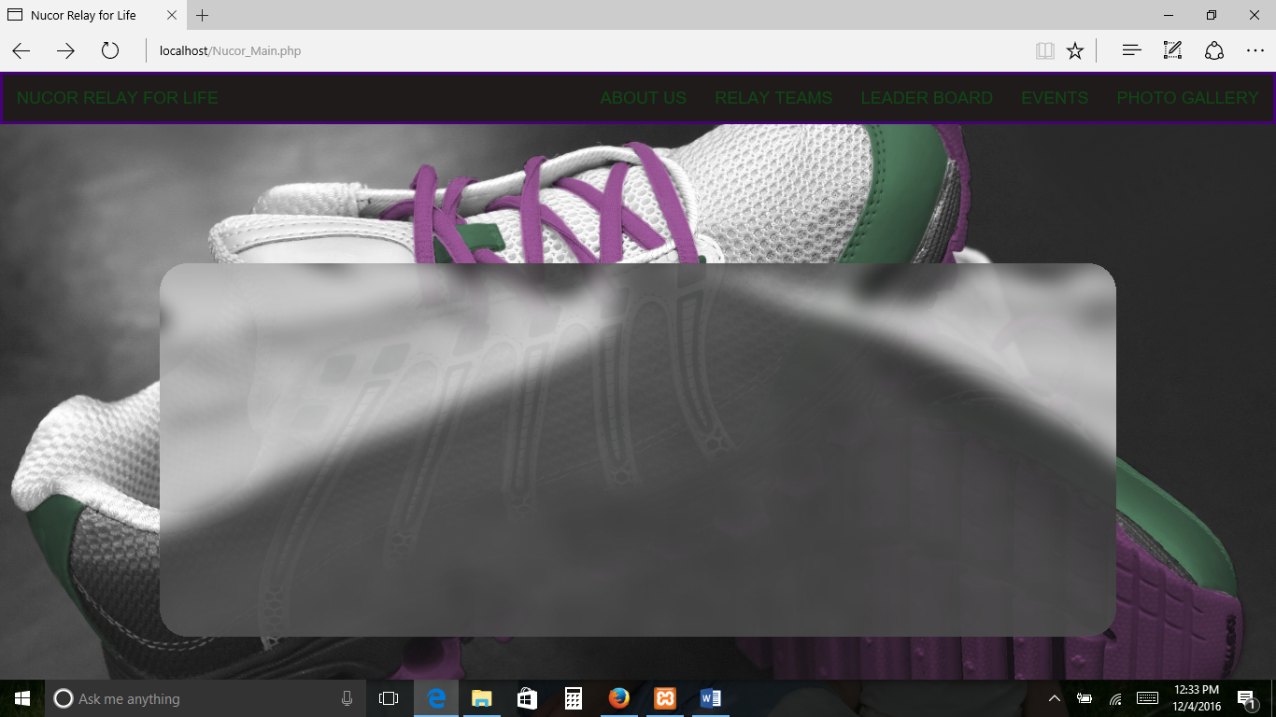

**2.2 About Us**

The following picture displays the output when the “ABOUT US” TAB is clicked

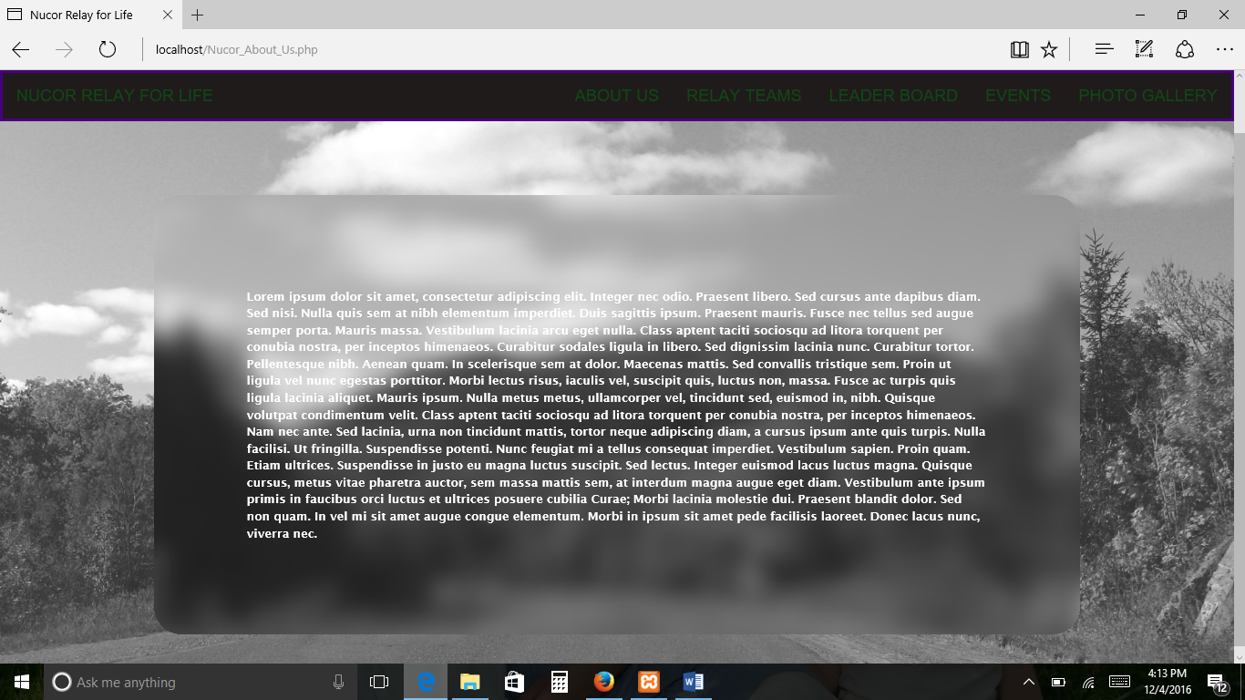

**2.3** **Relay Teams**

The following picture displays the output when the “Relay Teams” TAB is clicked

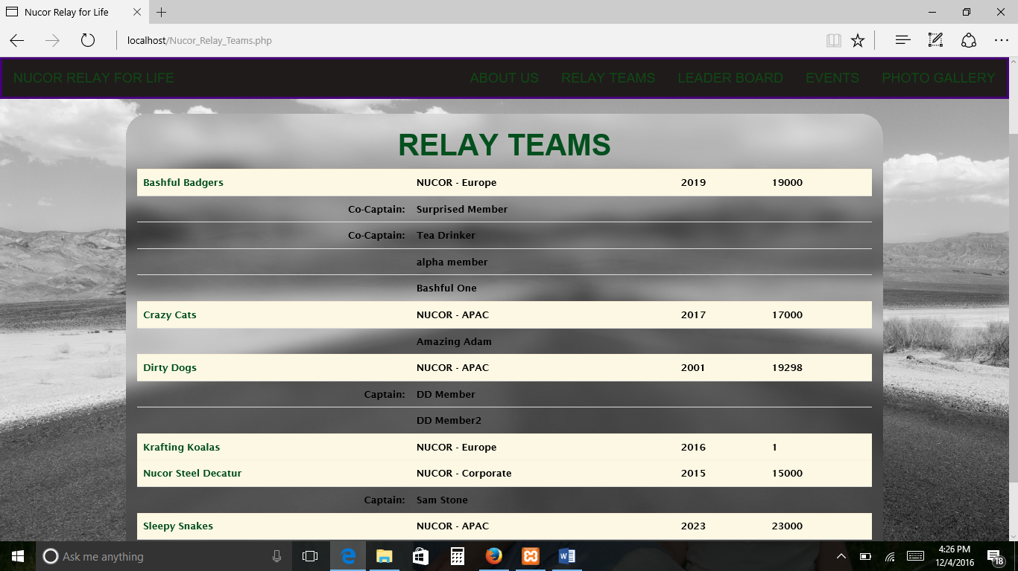

**2.4 Leader Board**

The following picture displays the output when the “LEADER BOARD” TAB is clicked

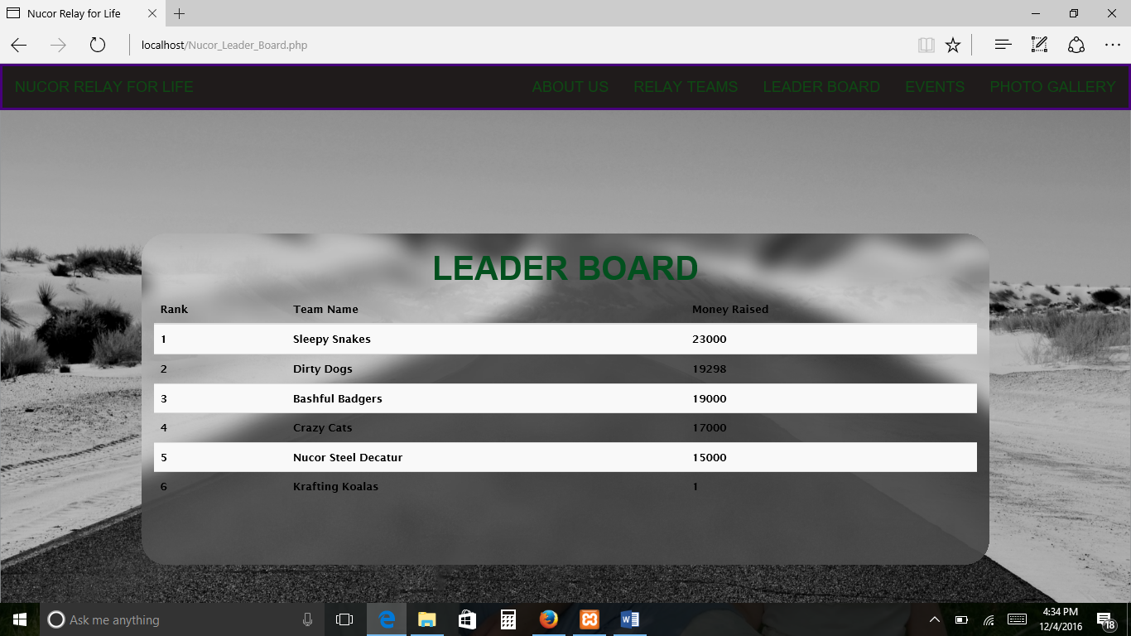

**2.5 Events**

The following picture displays the output when the “EVENTS” TAB is clicked

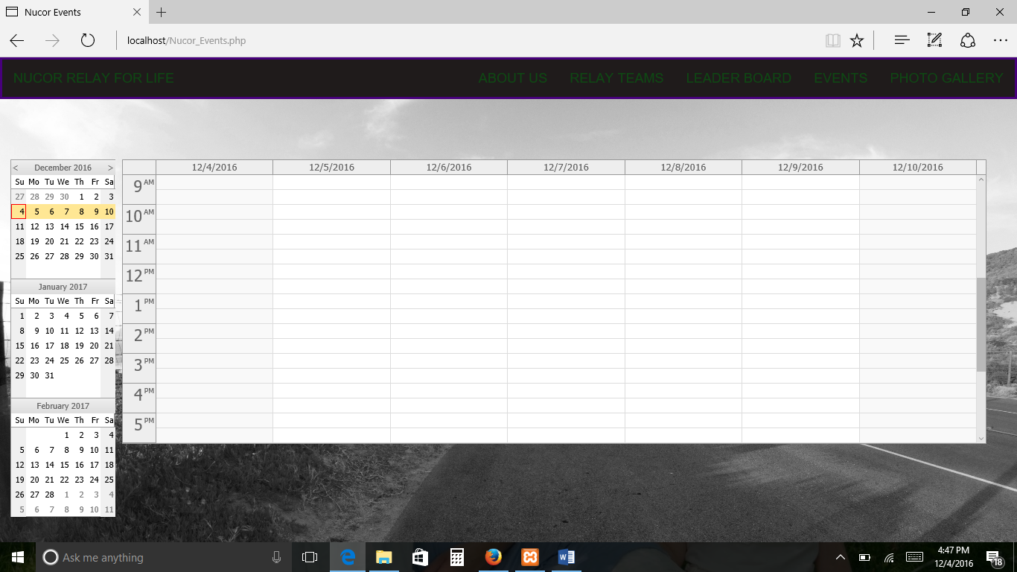

**2.5.1 Calendar**

Click the navigating TABS as pointed out by RED arrow in the picture to scroll through calendar of events

Select/click an Event from the DATE/TIME groups as pointed out by BLUE arrow to retrieve more information on that selected Event



**2.6 Photo Gallery**

The following picture displays the output when the “PHOTO GALLERY” TAB is clicked

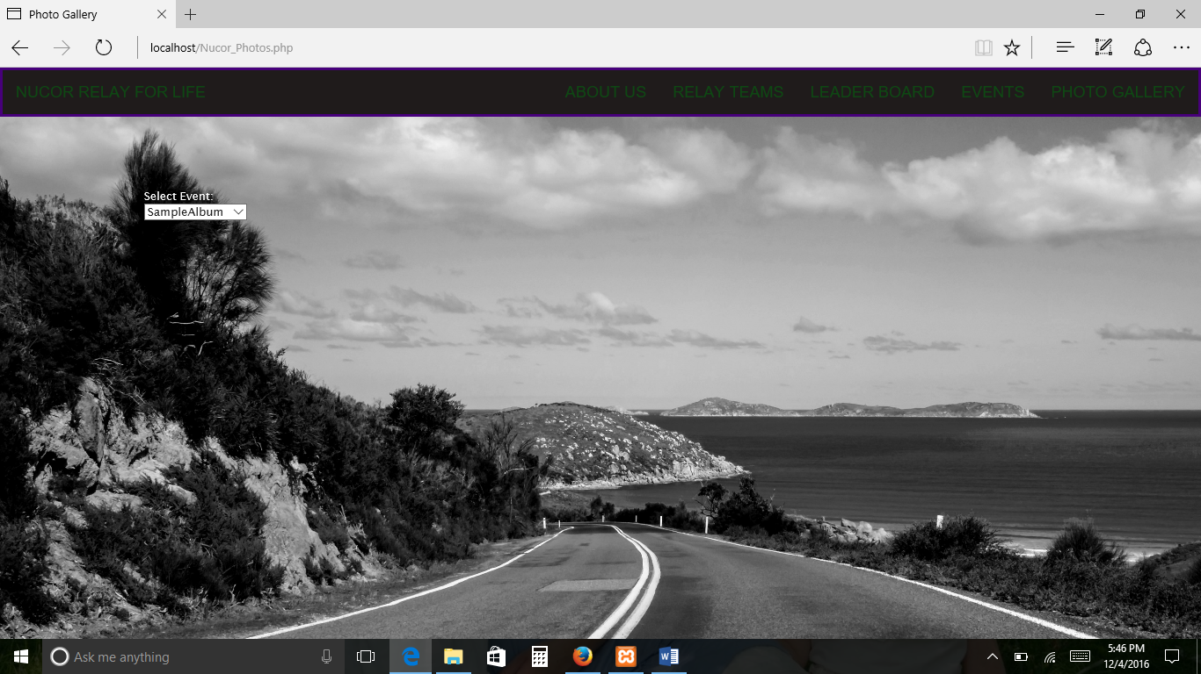

**2.6.1 Select Event**

Click the Drop down TAB and select/click and Event (Album) from list to view.

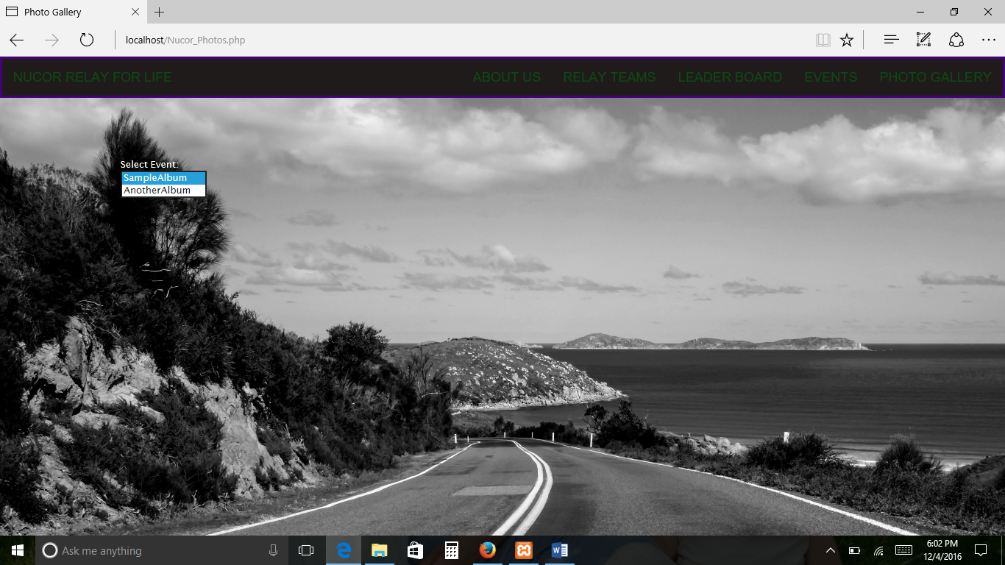

**(THIS PAGE INTENTIONALLY LEFT BLANK)**